**Scope:**

The purpose of this document is to describe steps involved in creating two new business units –OPT30 and PAN30 under UNFEM.

Modules : E-procurement/Purchasing, Account Payables and Asset Management including few common setups .

**SECURITY**

**\*\*\*\*\*\*\*\*\*\*\*\*\*\*\*\*\*\*\*\*scripts to be executed\*\*\*\*\*\*\*\*\*\*\*\*\*\*\*\*\*\*\***

1. SQL Scripts to be executed in Atlas Finance
2. **Row Level Security setup for the new UNFEM BU's (PAN30 & OPT30)**

*A. INSERT INTO PS_SEC_BU_CLS*

*SELECT 'PAN30' , business_unit FROM ps_bus_unit_tbl_fs;--529*

*B. INSERT INTO PS_SEC_BU_CLS*

*SELECT 'OPT30' , business_unit FROM ps_bus_unit_tbl_fs;--529*

*C. INSERT INTO PS_SEC_BU_CLS*

*SELECT DISTINCT(oprclass), ‘PAN30’ FROM PS_SEC_BU_CLS WHERE oprclass NOT LIKE*

*'EA%' and oprclass not in*

*(select oprclass from PS_SEC_BU_CLS where business_unit = 'PAN30');--234*

*D. INSERT INTO PS_SEC_BU_CLS*

*SELECT DISTINCT(oprclass), ‘OPT30' FROM PS_SEC_BU_CLS WHERE oprclass NOT LIKE 'EA%' and oprclass not in*

*(select oprclass from PS_SEC_BU_CLS where business_unit = 'OPT30');--234*

1. **Add the two new BU's to the WF Route control profile definition for PAN30 and OPT30**

*insert into ps_rte_cntl_ln values ('UN_BU_UNFEM_ALL', 'Business Unit','PAN30','PAN30');--1*

*insert into ps_rte_cntl_ln values ('UN_BU_UNFEM_ALL', 'Business Unit','OPT30','OPT30');--1*

B. **SQL Scripts to be executed in Atlas Enterprise PORTAL(UNDPPA) (for ARGUS)**

*insert into ps_un_bu_userpref values ('UNFEM','PAN','PAN30','Panama','Panama');--1*

*insert into ps_un_bu_userpref values ('UNFEM','OPT','OPT30','occupied palestine territory','OPT30');--1*

1. **Table Set Control updates *-***

*INSERT INTO PS_SET_CNTRL_REC(*

*SELECT 'OPT30',REC_GROUP_ID,RECNAME,SETID FROM PS_SET_CNTRL_REC WHERE SETCNTRLVALUE='AFG30' );--6018*

*INSERT INTO PS_SET_CNTRL_GROUP(*

*SELECT 'OPT30',REC_GROUP_ID,SETID FROM PS_SET_CNTRL_GROUP WHERE SETCNTRLVALUE='AFG30' );--347*

*INSERT INTO PS_SET_CNTRL_REC(*

*SELECT 'PAN30',REC_GROUP_ID,RECNAME,SETID FROM PS_SET_CNTRL_REC WHERE SETCNTRLVALUE='AFG30' );--6018*

*INSERT INTO PS_SET_CNTRL_GROUP(*

*SELECT 'PAN30',REC_GROUP_ID,SETID FROM PS_SET_CNTRL_GROUP WHERE SETCNTRLVALUE='AFG30' );--347*

*/\*\*\** ***SET CONTROL TABLE*** *\*\*\*/*

*UPDATE PS_SET_CNTRL_TBL A*

*SET SETID = 'UNFEM'*

*WHERE A.SETCNTRLVALUE IN ('PAN30')*

*AND SETID <> 'UNFEM'; -- rows ;*

*UPDATE PS_SET_CNTRL_TBL A*

*SET SETID = 'UNFEM'*

*WHERE A.SETCNTRLVALUE IN ('OPT30')*

*AND SETID <> 'UNFEM';*

*-- 1 rows ;*

1. ***Addition of Business unit in Paycycle .***

*We have made script s to add two business unit in paycycle PAN10B and PAL10A.*

*INSERT INTO ps_PYCYCL_BU (PAY_CYCLE,BUSINESS_UNIT,PROCESS_FLG)*

*VALUES ('PAN10B','PAN30','Y');--1*

*INSERT INTO ps_PYCYCL_BU (PAY_CYCLE,BUSINESS_UNIT,PROCESS_FLG)*

*VALUES ('PAL10A','OPT30’,'Y');--1*

*\*\*\*\*\*\*\*\*\*\*\*\*\*\*\*\*\*\*\*\*\*\*\*\*\*\*\*\*\*\*\*\*\*\*\*\*\*\*\*\*\*\*\*\*\*\*\*\*\*\*\*\*\*\*\*\*\*\*\*\*\*\*\*\*\*\*\*\*\*\*\*\*\*\*\*\*\*\*\*\*\*\*\*\*\**

**PURACHSING**

1. Location Setup

Go to 'Set Up Financials/Supply Chain -> Common Definitions -> -> Location -> Location'

Enter a new Location Definition

1. Add new Location ‘PAN30’

SetID - 'UNFEM'

Location Code – PAN30

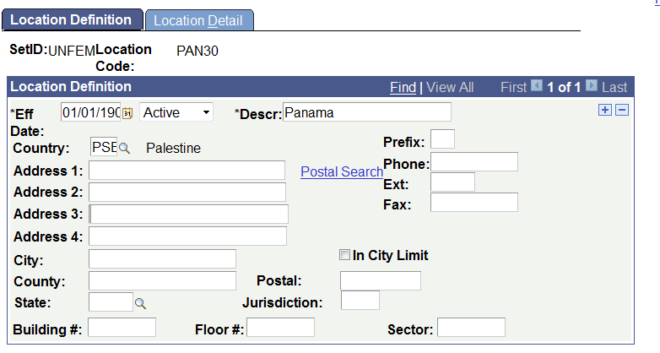

Go to ‘location Detail’ tab,: location detail panama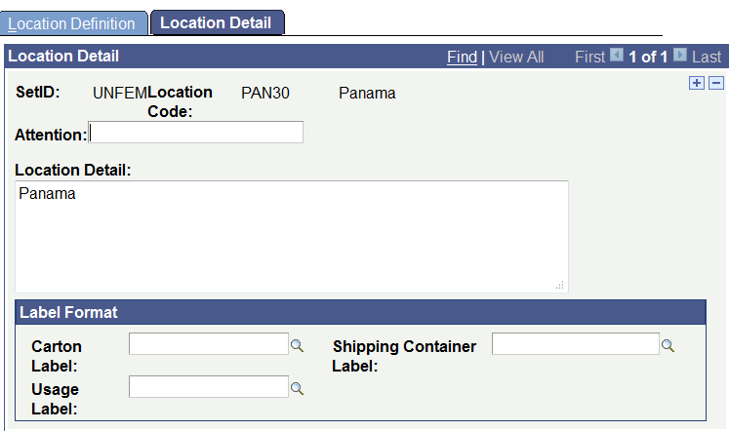

1. **Ship To Locations**

Go to 'Set Up Financials/Supply Chain > Product Related > Procurement Options > Ship To Locations'

1. Enter a new Ship to ID

SetID – ‘UNFEM’

Ship to Location – ‘PAN30’

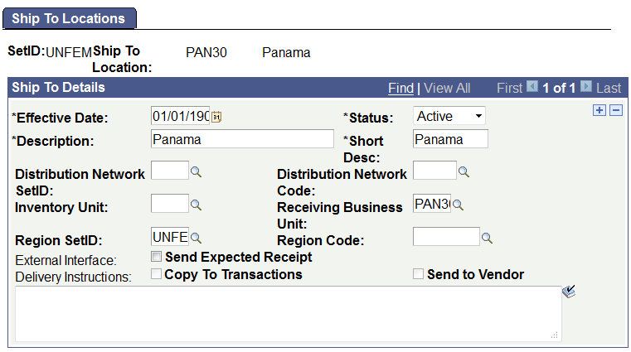

Click on ‘Sales/Use Tax’ link and enter the below configuration.

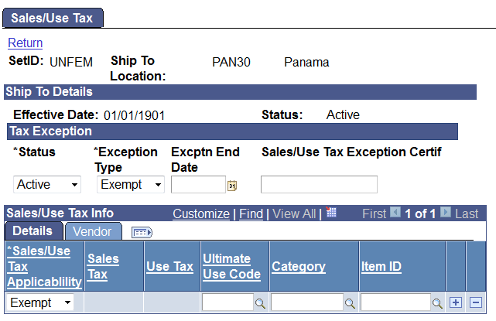

1. Asset Management Business Unit Definition

Navigation: Set Up Financials/Supply Chain -> Business Unit Related ->Assets-> Asset Management Definition – Add a New Value.

Enter new Business Unit ‘PAN30’ and click add.

On AM Business Unit Definition page enter the below configuration - 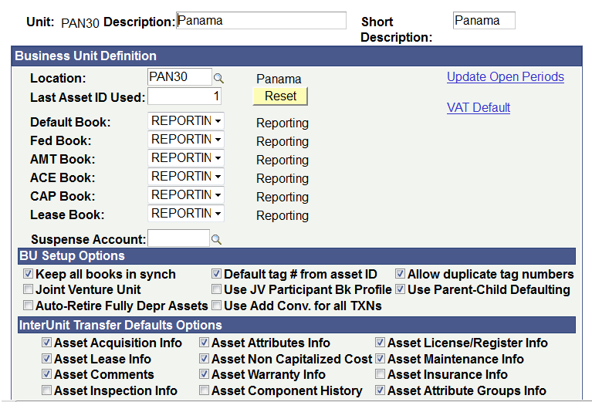

Go to ‘Business Unit/Book definition’ tab and enter the following configuration

Now select ‘Create Accounting Entries’ checkbox and enter the following

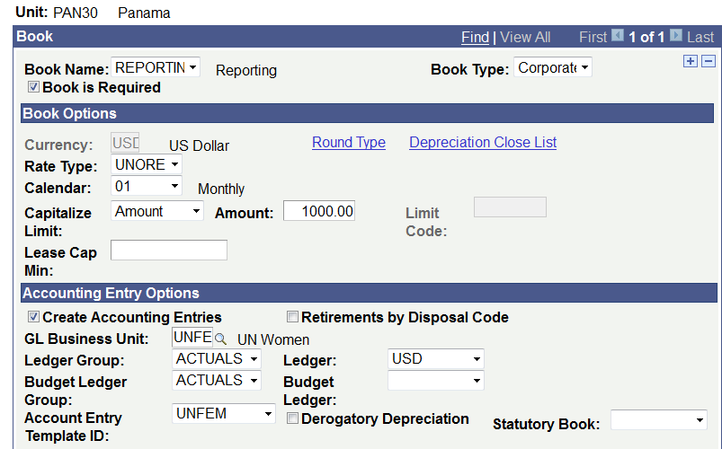

Now select ‘Create Accounting Entries’ checkbox and enter the following. NOW CLICK SAVE.

1. **Setting up Contract set control-NOT REQUIRED…**

Go to 'Set Up Financials/Supply Chain > Product Related > Procurement Options >Purchasing> Set Controls - Contracts'

Not Required.

1. Account Payables Business Unit Setup

Navigation->setup financial chain->business unit related->Payables definition

1. Add a new Accounts Payables Business Unit definition - 'PAN30'

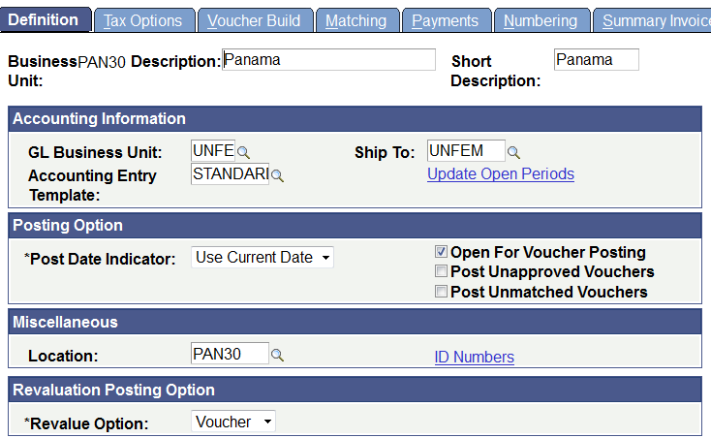

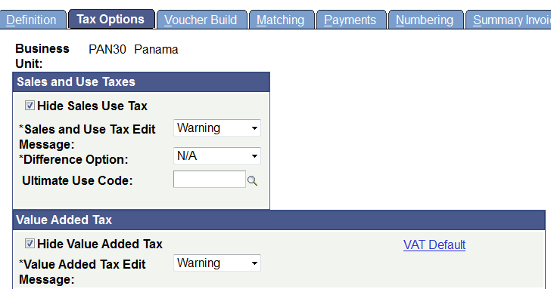

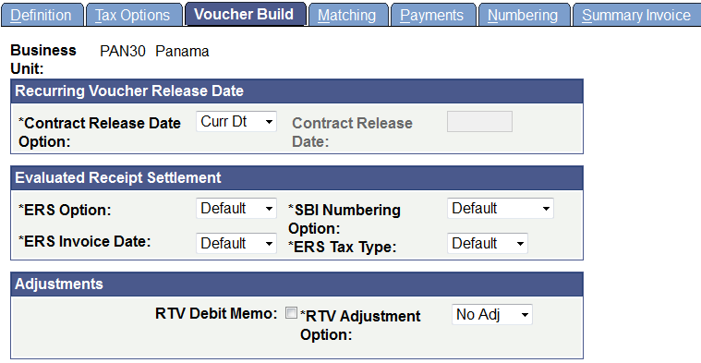

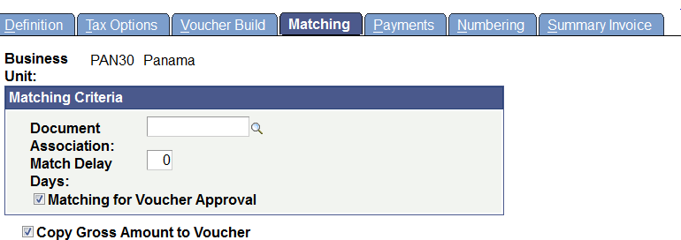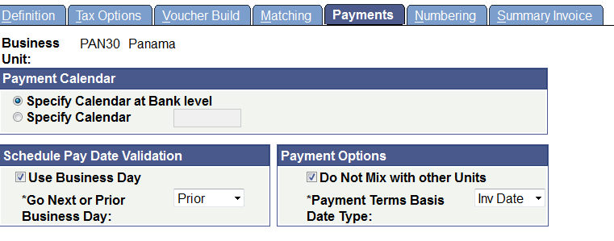

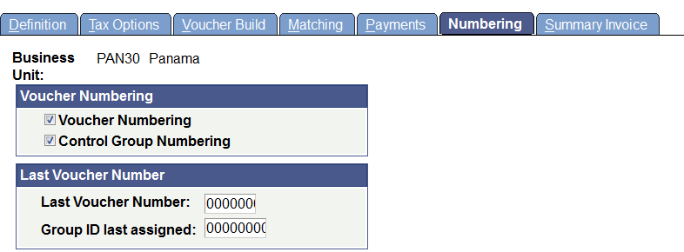

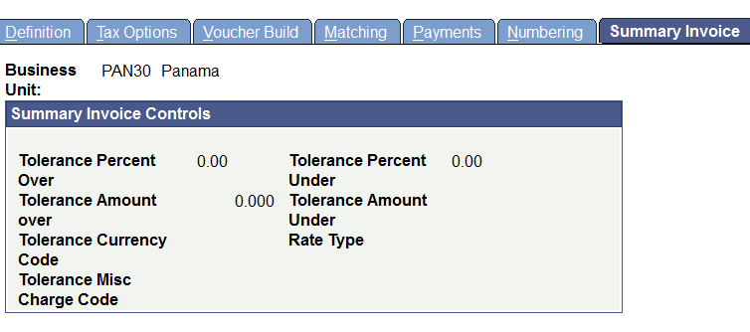

Navigation->setup financial chain->business unit related->Payables option

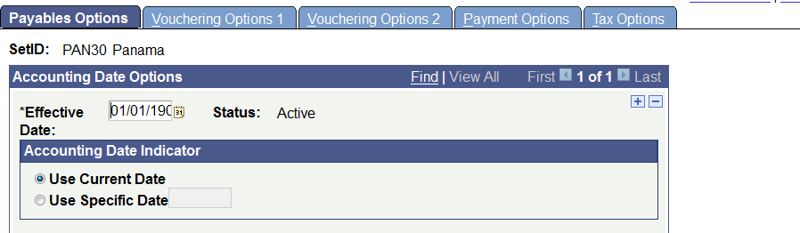

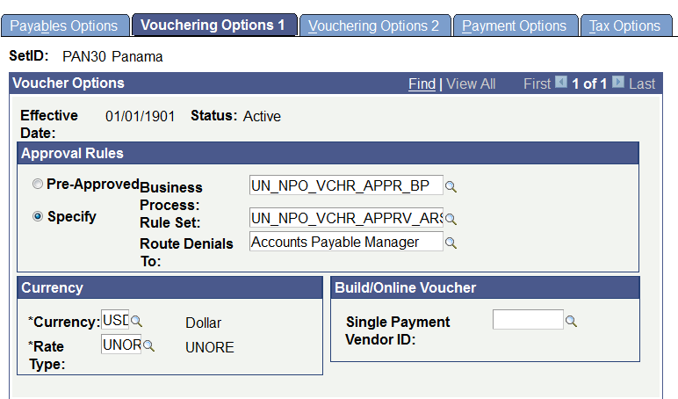

For OPT 30 use currency:NIS

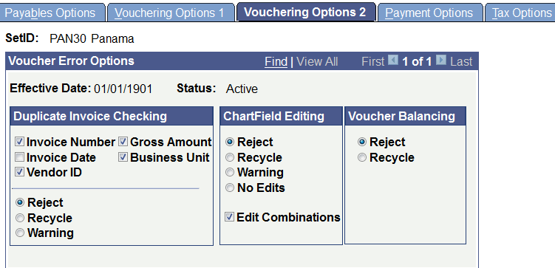

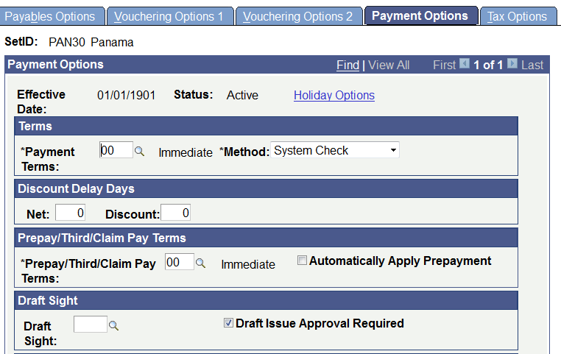

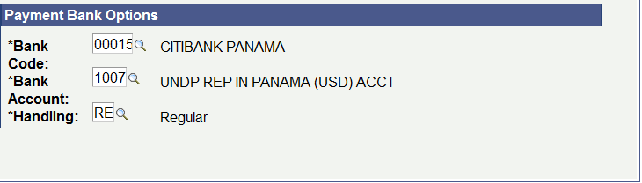

For OPT30 use below account:

Bank code        –00039 – Arab Bank PLC

Bank account – 1006 – UNDP REP PSE  (ILS  ) ACCOUNT

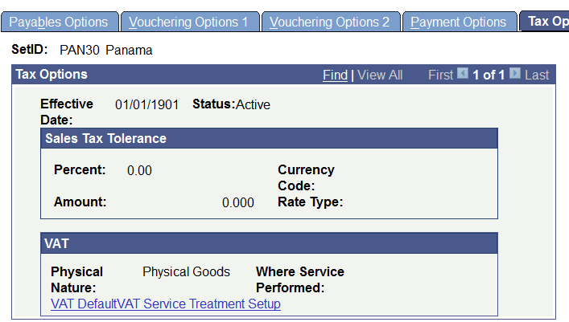

1. Purchasing Business Unit Set Up

Go to 'Set Up Financials/Supply Chain -> Business Unit Related -> Purchasing -> Purchasing Definition'

1. Add a new Purchasing Business Unit definition - 'PAN30'

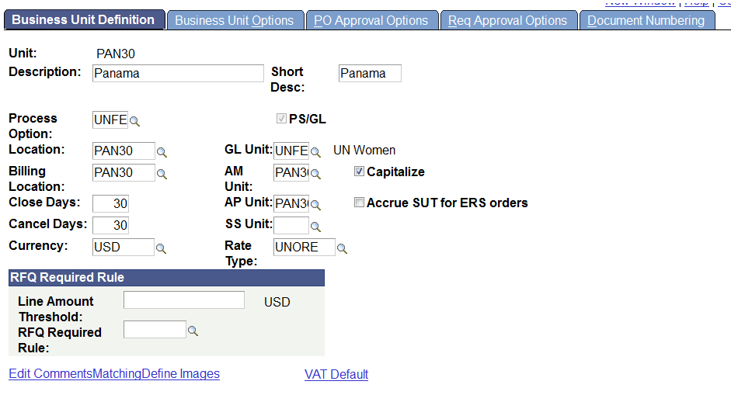

Click on 'Edit Comments' link on 'Business Unit Definition Page'.

Select Standard Comment Type as 'TAC' and Comment ID as 'MAIN'

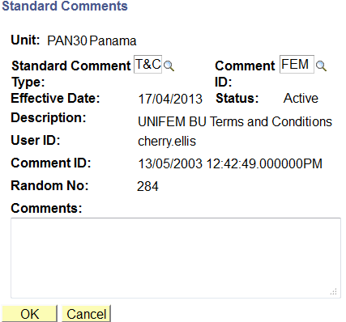

Click on 'Matching' link on 'Business Unit Definition Page'.

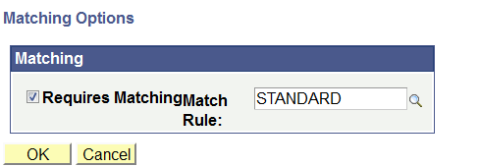

Click on ‘Business Unit Options’ tab and enter the below details.

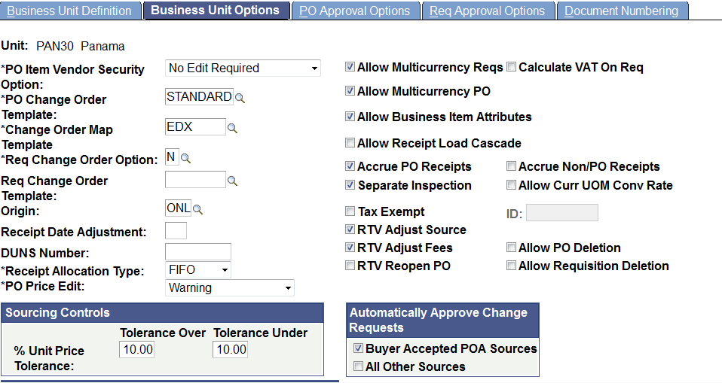

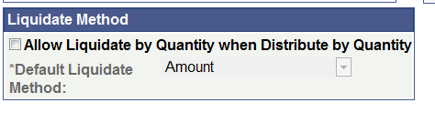

Go to 'PO Approval Options' tab

Select 'UN_PO_APPROVALS' as 'PO Approval Business Process'

Select 'PO Amount Approval Needed' option

Select 'UN_PO_APPROVAL_ARS' as 'PO Amount

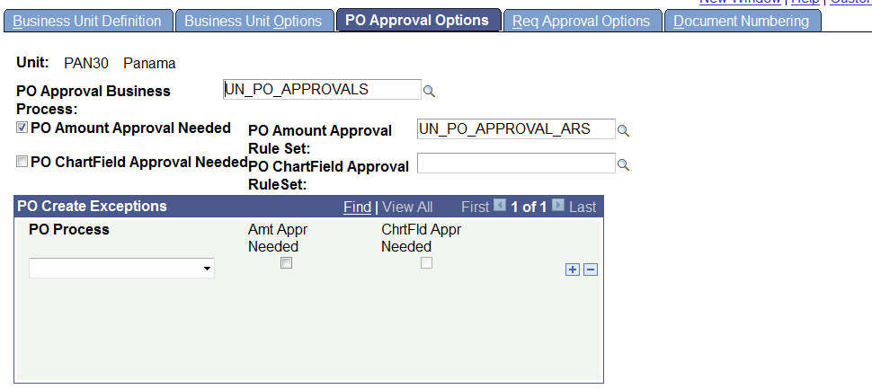

Go to 'Req Approval Options' tab

Select 'UN_REQ_APPROVALS2' as 'Req Approval Business Process'

Select 'Req Amount Approval Needed' option

Select ‘UN_REQ_APPRS_WO_BUYER_ARS’ as Req Amount Approval Rule'

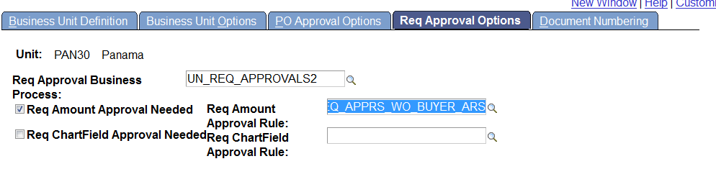

Got to 'Document Numbering' tab

Select all the options

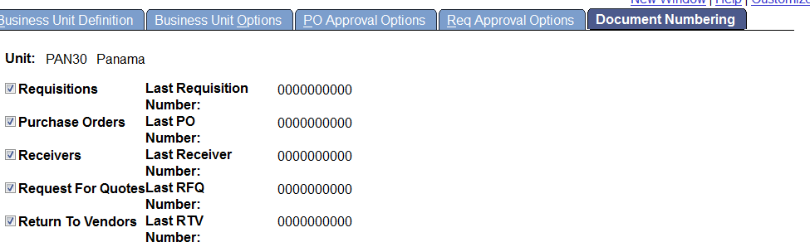

E-PROCURMENT work flow setting:

Navigation:eprocurment->Administer procurement->manage business units->e-procurement business unit options->

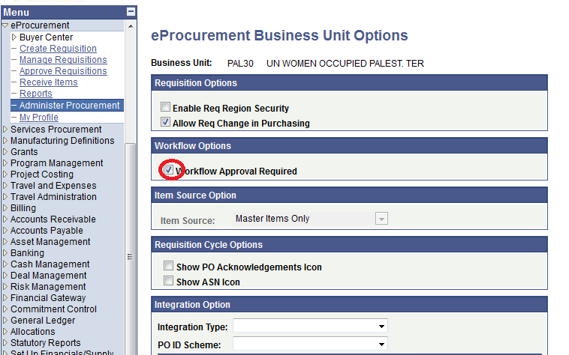

1. Vendor set control Set up

Navigation->setup financial chain->product related->vendors->set control vendors.

No setup is required for PAN30 because all vendors are created and used under

UNFEM setid.

1. Account Receivable Business Unit setup.

**No Account receivables setup is required because all are created and used under UNFEM.**